Lab 5-Soldering a PCB

## Learning Outcomes:

* Learn about PCBs
* Learn to solder a PCB

## Background:

Printed circuit boards (PCBs) are an important part of most modern electronics. Electronic circuits use many different components and these components communicate through the PCB. A PCB consists of a flat sheet of insulating material and a layer of copper. The copper layer is then mechanically or chemically etched into separate tracks called traces. These traces are the ‘wires’ of the pcb connecting each individual component in the proper manner.

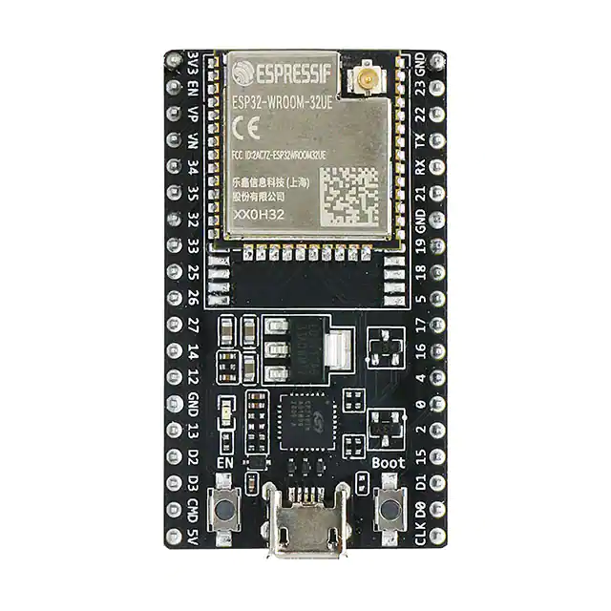

*Arduino Nano. Image courtesy of Digi-Key*

The esp32 above is on a PCB. The esp32 components are all mounted onto the PCB (blue wafer) and you can see it’s traces between the components on the front and back.

There are two different types of PCB components. One called through-hole and the other called surface mount. Each offers its own pros and cons. Through-hole components have leads that are inserted through holes on the board, thus the name, and soldered into copper traces on the other side. Through-hole manufactured boards are easier for humans to make because they are bigger than surface mounted components, however, they take up more space.

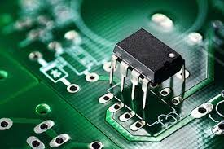

*Through-hole pcb. Image courtesy of* [*wellpcb.com*](https://www.wellpcb.com/plated-through-hole.html)*.*

Surface mounted PCB technology came about in the 1960s and gained widespread popularity by the mid-1990s. Components were designed to mount directly to the surface of the PCB. This cuts down on their size allowing more compact design. However, it makes manual soldering a pain. Robots are typically used to place and solder these components.

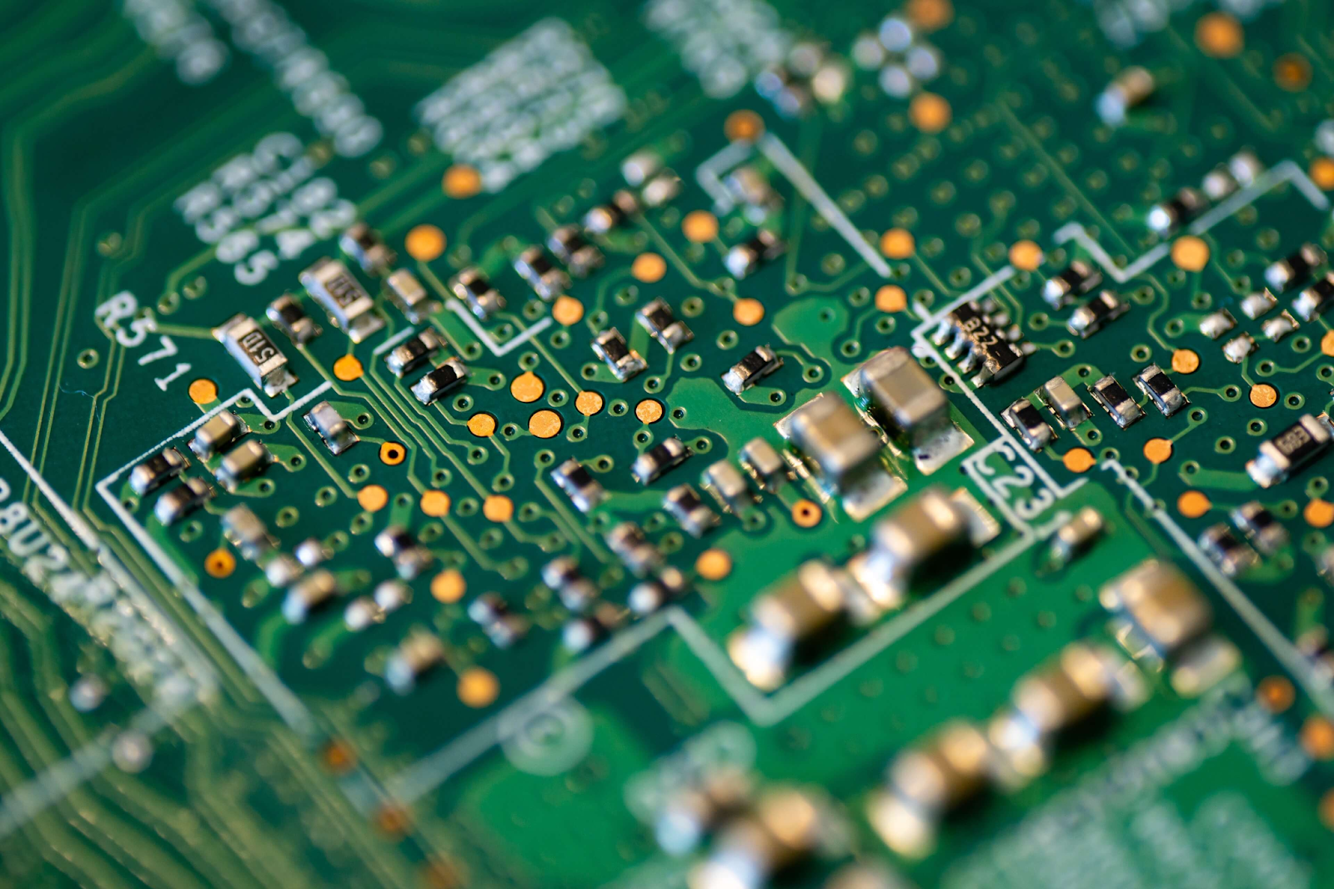

*Surface Mounted PCB. Image courtesy of* [*neodenusa*](https://neodenusa.com/blog/surface-mount-electronic-components)

The ELC has a PCB mill. The mill is a mechanical through-hole mill. Because it’s mechanical, the boards are pretty cheap but they are not as high quality as a chemical commercial PCB manufacturer. The copper PCBs in your kit are from the ELC PCB mill.

For the next part of this lab you will solder on components to your PCB and learn how to test for connectivity between each of them.

### Part 1 Solder a PCB:

**PICTURES!!!!!!!!!!!**

**Picture of the PCB I made**

**Picture of the eagle board?**

1. Gather your components (pcb, voltage regulator, switch, 0.1uF capacitor, 0.33uF capacitor, battery cap, 2 3-pin male headers, 1 4-pin female header, 2 15-pin female headers)
2. Find a solder station
3. Follow the board layout and solder each of your components to the top of the pcb.
4. As you’re going along use a multimeter set to connectivity setting 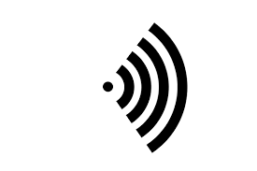 to check each connection on your pcb. For example, each trace should connect each of the pins part of its circuit but should not connect other traces. If you by chance have solder connecting two different traces then you have a shorted circuit. That will make your car fail. (look at lab 1 for extra material on testing connectivity)

Once you’ve finished your PCB should look something like this:

**Picture of completed PCB**

If you’ve checked to make sure you didn’t short anything, place your esp32 into the headers pins. Make sure to check the orientation.

### Part 2 Test the PCB:

Try inserting and testing a servo using the code provided from lab 3, or inserting and testing the HC-SR04 ultrasonic sensor from lab4. If you soldered your PCB correctly you should get the same results as before.